##### Crossbody Bag

1. 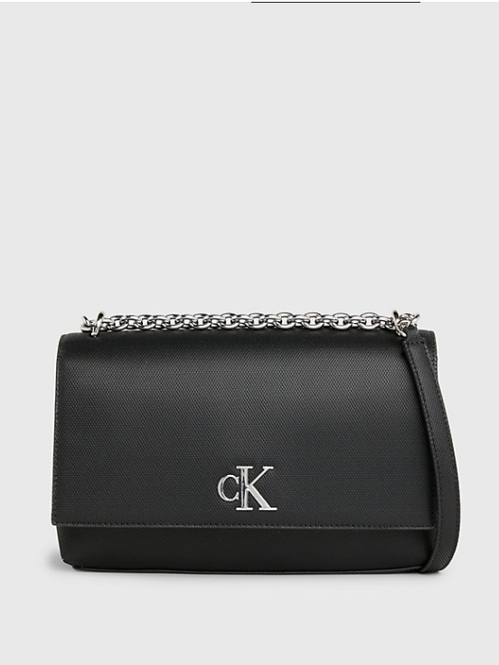**Classic Elegance**: Opt for a sleek and minimalist black crossbody bag with clean lines and subtle hardware for a timeless and sophisticated look. Pair it with a tailored blazer, a crisp white button-down shirt, and black trousers for a polished office outfit.
2. **Casual Chic**: For a laid-back yet stylish ensemble, pair your black crossbody bag with distressed jeans, a graphic t-shirt, and a leather jacket. Add a pair of sneakers or ankle boots to complete the effortlessly cool vibe.
3. **Evening Glamour**: Elevate your evening attire with a black crossbody bag featuring elegant details like sequins, studs, or metallic accents. Pair it with a little black dress, statement earrings, and strappy heels for a glamorous night out on the town.
4. **Boho Vibes**: Embrace a bohemian-inspired look by pairing your black crossbody bag with a flowy maxi dress, layered jewelry, and ankle boots or sandals. Add a floppy hat and oversized sunglasses for a chic and free-spirited ensemble.
5. **Monochromatic Ensemble**: Create a chic monochromatic outfit by styling your black crossbody bag with black clothing pieces in varying textures and finishes. Experiment with different shades of black, such as charcoal, ebony, and jet black, to add depth and dimension to your look.
6. **Pop of Color**: Use your black crossbody bag as a canvas to showcase a vibrant pop of color. Pair it with colorful clothing pieces or accessories, such as a bold red coat or a statement scarf, to add visual interest and contrast to your outfit.